Credit card Report

Transactions report

***This dashboard provides a comprehensive analysis of customer spending patterns across various card types and occupations, aiming to identify high-revenue segments and inform targeted marketing strategies.***

**Insight #1**

From the revenue of use type chart the **online transaction** was generated around **3M** , significantly lower than **swipe(35M)** and **chip(17M)** , which leads to show least contributor in transaction type chart.

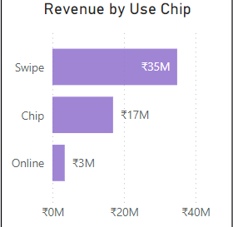

**Purpose the solution :**

"To encourage customers to use online transactions more, we can introduce targeted **offers and perks**, such as:"

* **Cashback Rewards** for online payments.
* **Discounts** on specific categories like groceries or entertainment.
* **Loyalty Points** for every online transaction that can be redeemed later.
* Limited-time **voucher rewards** for high-value online purchases.

**Expected Impact**:

* "These initiatives can make online transactions more attractive, increasing their usage while boosting overall transaction volume and revenue."
* This strategy can tap into **digital-savvy younger customers** who prefer online payments.

**#insight 2 ( positive impact )**

Q3 peak performance

**Observation :**

* Q3 generated 14.2 revenue and had 166.6k transaction which were highest from whole year

**Possible Reasons for Q3 Peak**:

* Promotions, festivals, or seasonal events might have driven higher spending.
* Customer engagement activities like offers or loyalty rewards could have worked well.

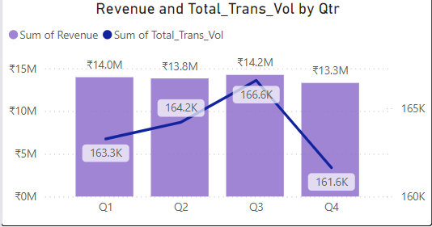

**#insight 3**

Steady revenue but fluctuating transactions

**Observation :**

* **Revenue** remains consistent across quarters (₹13.8M–₹14.2M), indicating stable spending.
* However, **Transaction Volume** fluctuates slightly, peaking in **Q3** at **166.6K** and dropping to **161.6K** in Q4.

**Insight :**

* Even though the transactions decreased in the Q4 but the revenue didn’t dropped significantly .
* This suggests that customers made **higher-value transactions** in Q4, compensating for the lower transaction count.

**Solutions :**

* Analyze customer behaviour during Q3 to replicate successful strategies.
* Collect customer feedback to identify and address any problems which leads to cause lower transaction rate.

**Insight #4**

Hight revenue from blue card transactions

**Observations :**

* Blue card users are most likely businessman , which generated over 12m revenue throughtout the year
* The difference of revenue between white collar and self employed customers were significantly not high and close to businessman

**Suggestions :**

* **Focus on targeted promotions and offers** to attract white collar and self employed customers to increase their further spending .
* **Engage through tailored campaigns** that address the unique needs and spending patterns of white-collar and self-employed groups.

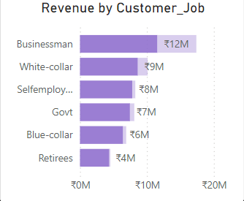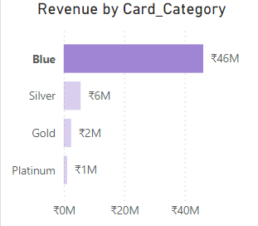

Customer report

**This dashboard shows that revenue is driven by high-income, married, and middle-aged customers, with self-employed individuals leading in client count. Top states like Texas, New York, and California contribute the most, while opportunities exist to grow revenue in other regions and promote personal loans to untapped customers.**

**Insight #1**

**Observation:**

* Females in the mid-income group generated more revenue than males during several weeks.
* Surprisingly, high-income group females spent less compared to mid-income group females.

**Suggestions:**

* Launch targeted campaigns for high-income group females with exclusive offers at popular shopping outlets.
* Conduct a survey or analysis to understand why high-income group females are spending less or losing interest in using credit cards.

**Insight #2**

**Observation :**

* Tx , NY ,CA were found they same high revenue rate and generated around same revenue from year due to high industrialization and employment
* FL and NJ trail behind maybe due to lack of jobs and urbanization , lack of job opportunities , that’s why peoples spending less

**Suggestions :**

* Collaborate with local businesses and merchants in these states to create spending incentives and attract more card usage.
* Analyze the specific spending behavior and challenges in FL and NJ to tailor solutions that resonate with the local population.

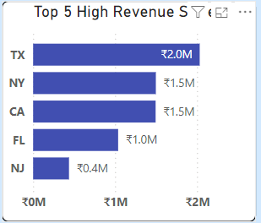

*Additional Insights Without Focusing on Revenue*

**Insight #3**

**Customer Demographics & Behaviour Insights**

**Observation:**

* Most **self-employed individuals** and **businessmen** tend to have higher client counts, reflecting a strong presence of small business owners or freelancers.

**Insight:**

* These segments may benefit from tailored credit products or services designed for small business needs, such as credit limits or rewards tailored to business expenses.

**Suggestions :**

* Provide tools and consultancy program for **expense management** and **financial planning** to assist small business owners in tracking and optimizing their spending.

**Insight #2**

**Observation:**

* A significant portion of **self-employed** and **businessmen** do not own their own homes.
* Despite this, they contribute significantly to revenue growth.

**Insight:**

* The difference in revenue generated by **homeowners** versus **non-homeowners** is relatively small, with only around ₹8M separating the two groups.
* This suggests that **homeownership status** may not be a strong determinant of revenue contribution or creditworthiness.

**2. Marital Status Insights**

* **Observation:**
  + **Married customers** contribute the highest revenue, followed by singles.
* **Insight:**
  + Married individuals may have higher financial commitments, suggesting a need for tailored credit products like family-oriented benefits or shared account op

**Insights #3**

* **Observation:**
  + **Married customers** contribute the highest revenue, followed by singles.
* **Insight:**
  + Married individuals may have higher financial commitments, suggesting a need for tailored credit products like family-oriented benefits or shared account op

Conclusion

*The main motive from both dashboards is to identify key customer segments contributing to revenue growth, understand their behavior patterns, and implement targeted strategies that enhance credit card usage and drive consistent revenue. By focusing on demographics like self-employed individuals, mid-income group females, and regions like TX, NY, and CA, financial institutions can tailor their offerings to boost credit card adoption, reduce perceived risks (like homeownership), and capture untapped markets.*